JODIE LAU jodielaucq@gmail.com | 602-463-6090 | Tempe, AZ

Portfolio with writing samples from USA TODAY.

1. I wrote these three refers on the front page of USA TODAY’s weekend edition, Sept. 29-Oct. 1, 2023
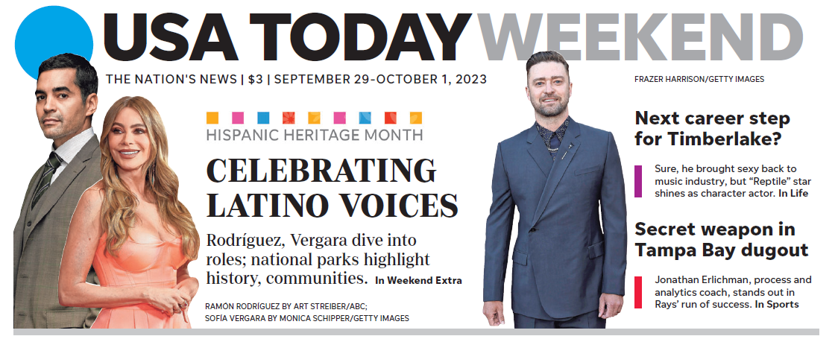

2. I wrote these three refers on the front page of USA TODAY, Sept. 5, 2023
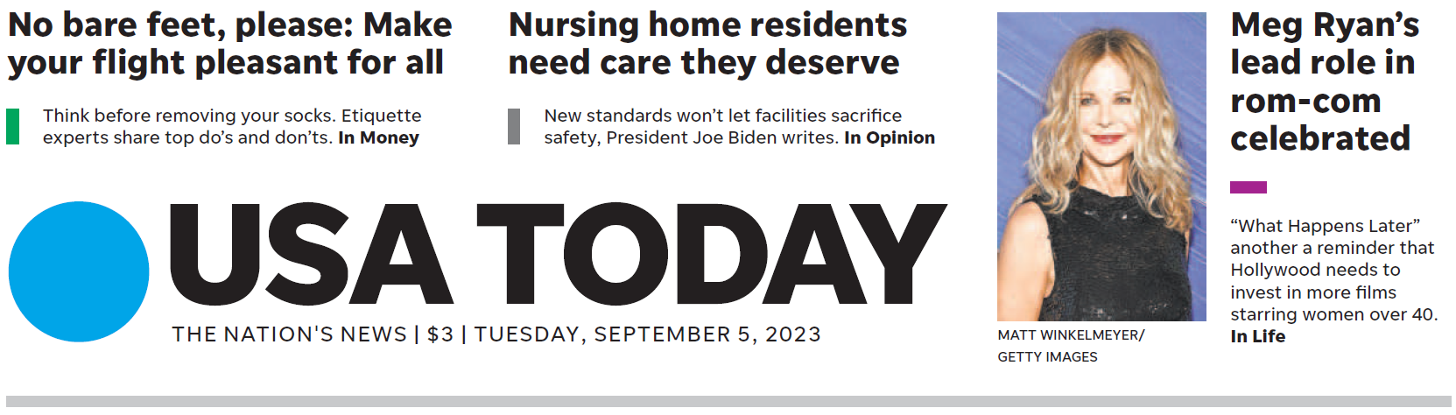

3. I wrote these three expanded refers on the front page of USA TODAY, Oct. 24, 2022
